ZTBMS SYSTEM MANUAL
INDEX
1. SYSTEM LAYOUT AND REQUIRMENT 3
1.1 System layout 3
1.2 Requirement 3
2. INSTALLATION 4
2.1 Start install NEXT button click. 4
2.2 Accepted License Agreement and click Next button. 4
2.3 To continue, click next, if you would like to select different folder, click browse button 5
2.4 To continue, click next, if you would like to select different start menu folder, click browse button. 5
2.5 Click install to continue with the instruction. 6
2.6 Install Database engine. 6
2.7 Install security module of GBMS. 7
2.8 Complete Installation. 8
3. Start program and Login Program 9
3.1 Setup Database 9
3.2 Login 10
4. Setup SYSTEM (Only Administrator) 12
4.1 Setup network 12
4.2 Setup user 13
4.3 Monitoring Area 14
5. Setup environment for system (Only Administrator) 15
5.1 STATUS CODE 15
5.2 BUILDING CODE 16
5.3 Floor code 17
5.4 ZONE CODE 18
5.5 Device 19
5.6 Assign CCTV 20
5.7 Member 21
5.8 Member of Send email & SMS 22
5.9 Confirm Message 23
6. MAIN SCREEN 24
6.1 Main screen layout 24
6.2 Device View 25
6.3 Card access view 26
6.4 Alarm view 27
6.5 Door status view 28
6.6 Map View 29
6.7 Send SMS & E-Mail 29

7. Report 30
7.1 Event log 30
7.2 SMS Log 31
7.3 Card Access Log 32
7.4 Admin Log 33

1. SYSTEM LAYOUT AND REQUIRMENT

1.1 System layout
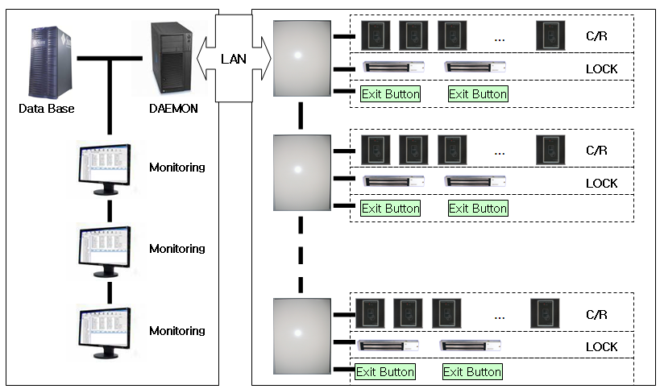

1.2 Requirement

- Required to connect to DAEMON Server.
- Required MS-SQL Server or PostGresql Server for save to Data.
- Required Computer that can run for Windows XP
- Required Administrator account in Installed Computer.

2. INSTALLATION
Run file SETUP.EXE.
Need administrator rights to install a program

2.1 Start install 서버프로그램설치 button click.
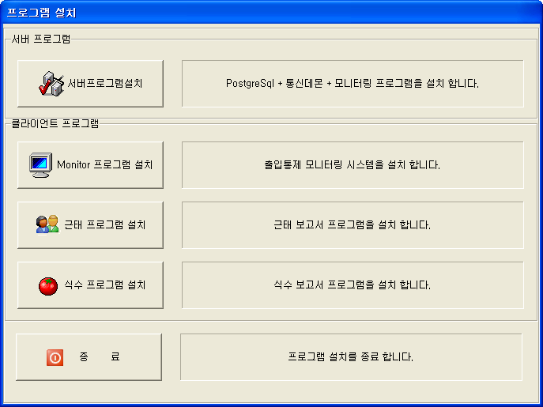

2.2 To continue, click next, if you would like to select different folder, click browse button
Default folder is c:\Programfiles\zeron\ZTBMS

2.4 To continue, click next, if you would like to select different start menu folder, click browse button.
Default is ‘AMS’
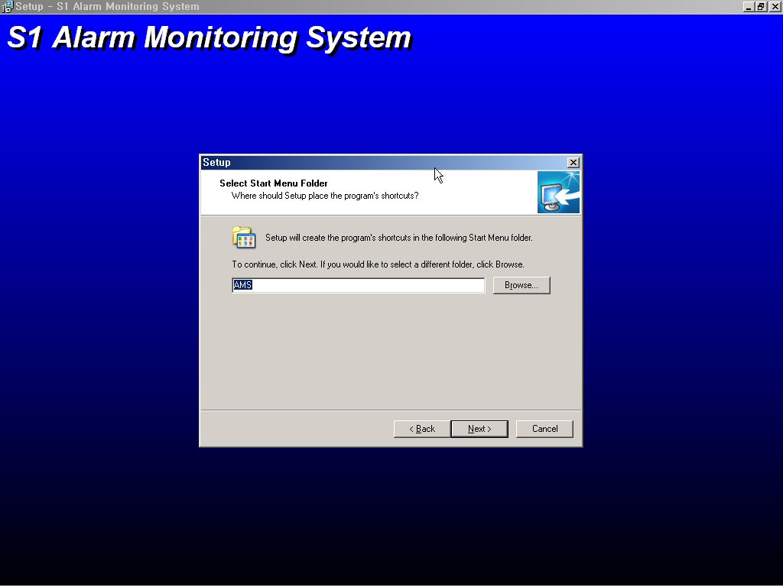
①
②

2.5 Click install to continue with the instruction.
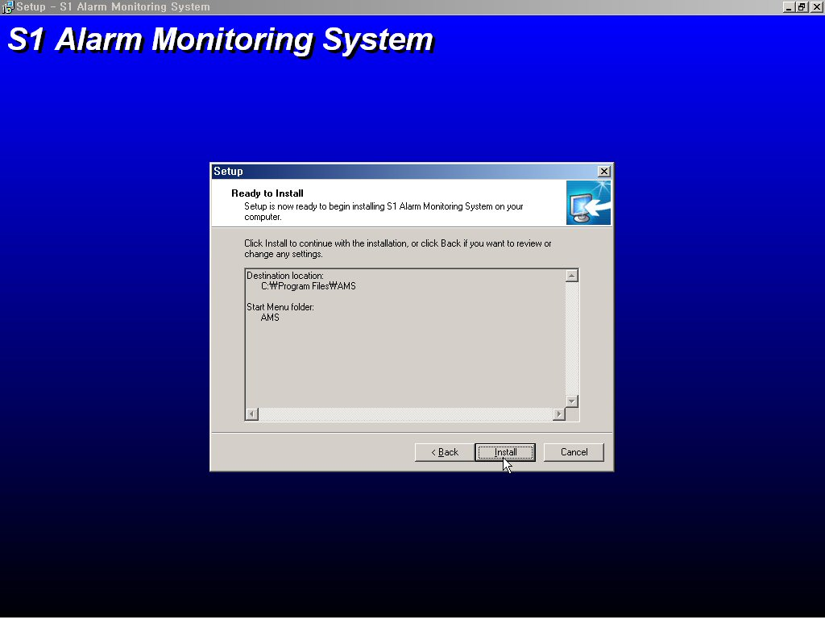

2.6 Install Database engine.
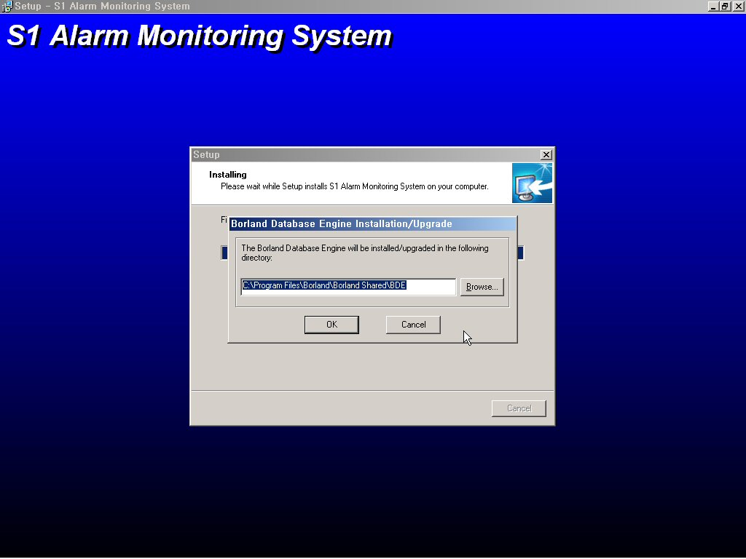
Click OK to continue.

2.7 Install security module of GBMS.

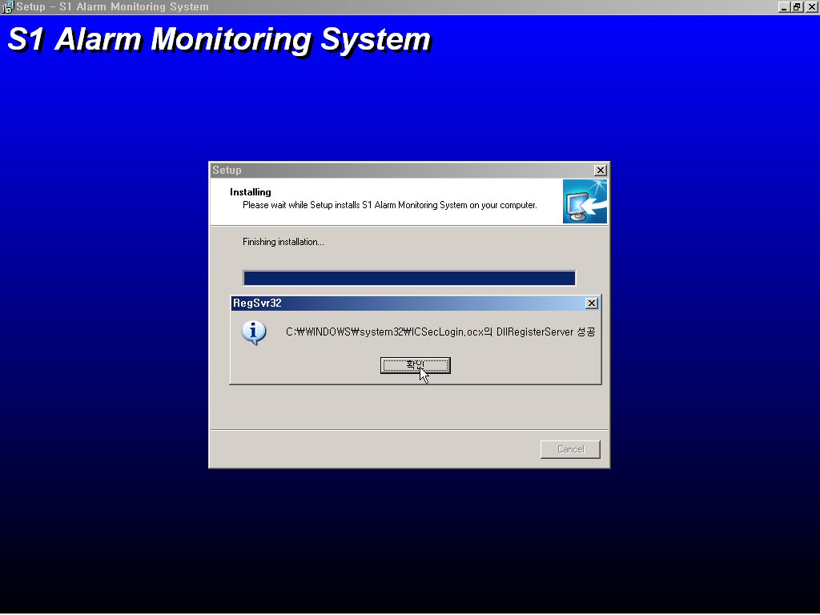

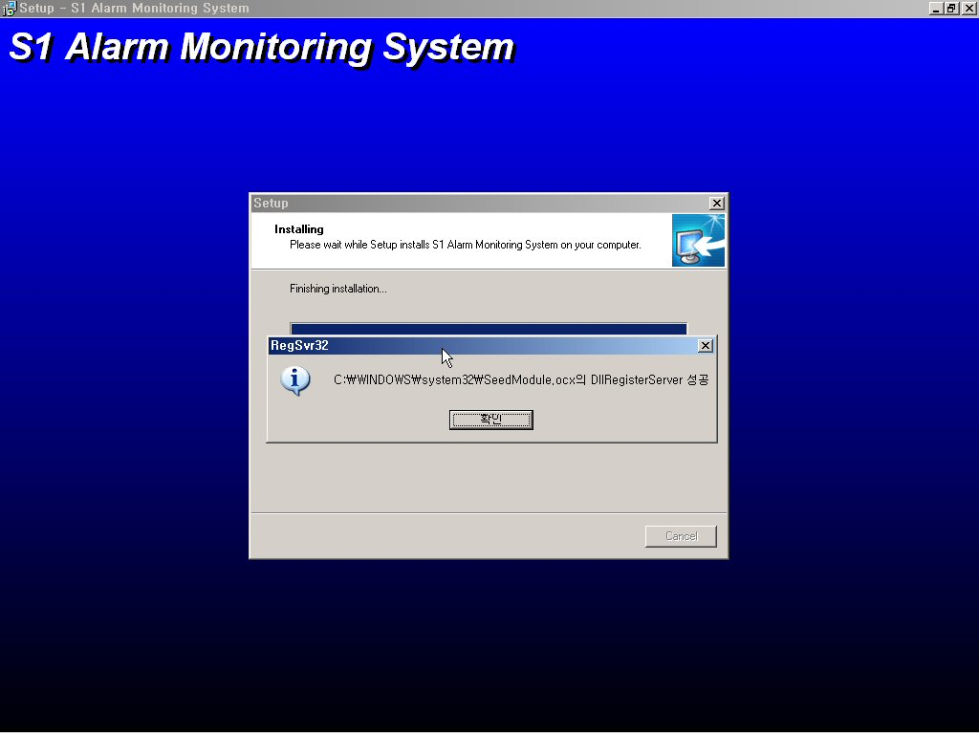

2.8 Complete Installation.
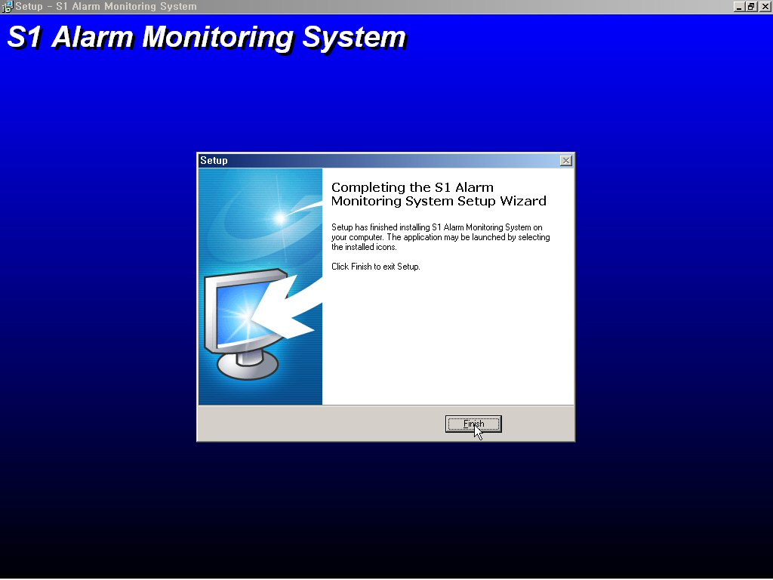

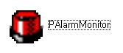
3. Start program and Login Program
From the windows desktop, click PAlarmMonitor

3.1 Setup Database
The first time you installed the program, select database.
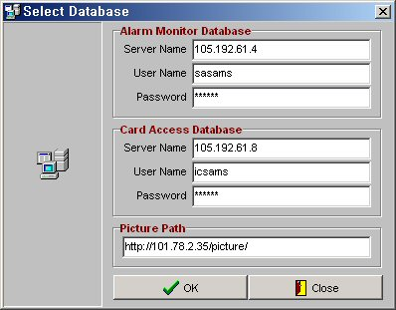
①
②
③
④
⑤
⑥
⑦

Alarm Monitor Database
① Input DB Server Name or IP address (105.192.61.4)
② Input User Name.(sasams)
③ Input Password.(sas514)
④ To completed, click OK.
Card Access Database
⑤ Input GBMS DB Server Name or IP address (105.192.61.8)
⑥ Input User Name.(icsams)
⑦ Input Password.(cnfdlq)
⑧ Input Picture Path(http://101.78.2.35/picture/)
④ To completed, click OK.

3.2 Login
To login system, you should select master access or Monitor access.

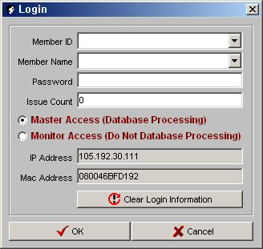
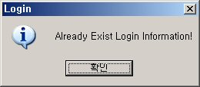
①
②
③
④
⑤
⑥
⑦
⑧
⑨

① Input or select Member ID that registered in GBMS.
② select Member name then registered this system.
③ Input password that registered in this system.
④ Input issue count that registered in GBMS
⑤ Select “Master access” that can control door and Send E-mail, SMS and register device .
Select “Monitor Access” that can control door and monitoring
★ You must runed one Master system only.
★ If you run more than one master Access, it may cause unexpected error in system.
★ If you don’t run master Access, this system don’t save alarm data in database.
⑥ View IP Address and MAC address in your PC
⑦ if you abnormal exited in system, you see “Already exist information”.
Click the clear login information button.
⑧ To completed, click OK.
⑨ if you want to cancel, click Cancel.

If failed to connect to Database, popup the windows of error message click ok to close.
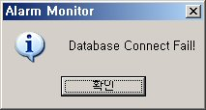

If incorrect ID and password, popup the windows of error message
click ok to close.
Check the ID and password in registered in GBMS.

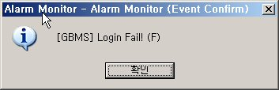

4. Setup SYSTEM (Only Administrator)

4.1 Setup network
To see this window, select main menu bar → system → Communication setting
Setup for connect GBMS application Server.
Setup for RS-232 communication port of CCTV matrix
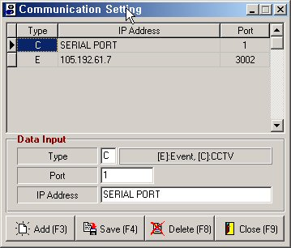
①
②
③
④
⑤
⑥
⑦

- Input Device type
C: CCTV Matrix
E: EVENT SERVER (GBMS)
- Input Port No
Type C: Input serial Port No
Type E: Input “3002” that is default Port no
- Input IP address
Type C: Input “SERIAL PORT” (not use)
Type E: Input ID address of GBMS server
- To add Communication port, click Add[F3]
- To save in edit or add, click, Save[F4]
- To delete data in selected, click Delete[F8]
- To close, click close[F8].

4.2 Setup user
You create user (Administrator, Operator).

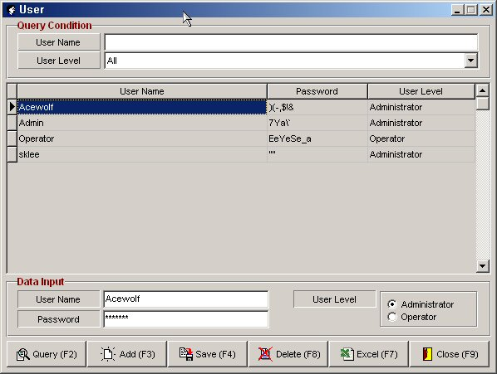

Operator: Control device, monitoring alarm.
Administrator: Operator function, Setup device, delete accrued alarm data.

4.3 Monitoring Area
To want to view limit, Select build combo box.
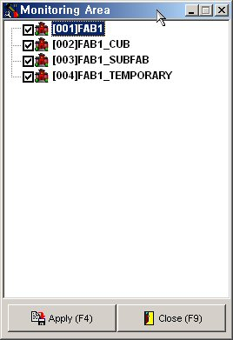

5. Setup environment for system (Only Administrator)
Make primary data for system.

5.1 STATUS CODE
Register STATUS CODE.
Don’t modify STATUS CODE in regesterd in GBMS
You can modified STATUS NAME.
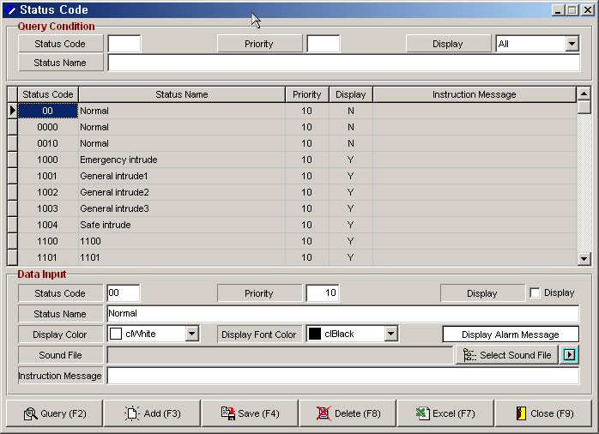
③
①
②

- Query Condition
Input condition for search data.
Click query button or F2.
- Data Input.
Status Code: This is Registered in GBMS
Don’t delete status code.
if you deleted status code, don’t receive alarm data.
Priority: Select a priority so that when several alarms occur simultaneously,
this alarm displays in order to priority.
Highest priority is 1.
Display: Decided display event or not.
Display color: Select an event color of background color and font color.
Status Name: Description of STATUS CODE
Instruction message: Type an alarm instruction for operator to fallow.
Select sound file:
- Query[F2] : To execute Query, click Query[F2]
Add[F3]: To create a new status code, click Add[F3]
If you want to create a new status code, have conference with S1.
Save[F4]: To save in edit or add, click Save[F4].
Delete[F8]: To delete, click Delete[F8]
Excel[F7]: To export to excel, click Excel[F7]
Close[F9]: To close, click Close[F9]

5.2 BUILDING CODE

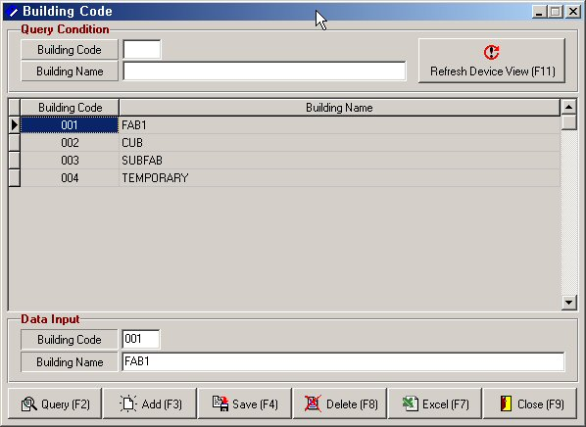
①
②
③
④

- Query condition: Input the query condition.
- Refresh Device View[F11]: if refresh device view, click Refresh device[F11].
If you don’t click this button, you don’t this building in device view.
- Data Input: Input Building Code and Building Name.
- Query[F2] : Execute the Query.
Add[F3]: Create a new Building code.
Save[F4]: Save Data in the adding or editing data.
Delete[F8]: Delete registered code.
Excel[F7]: Export to excel.
Close[F9]: Close this form.

5.3 Floor code
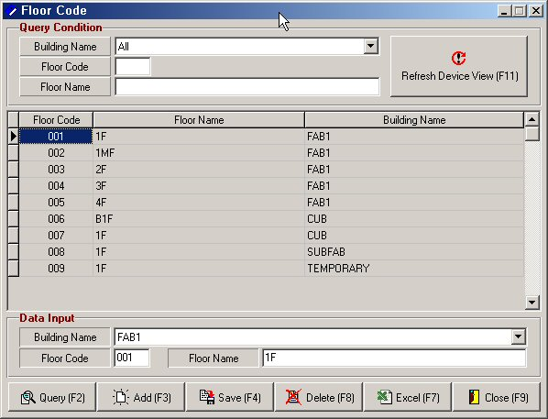
①
②
③
④

- Query condition: Input the query condition.
- Refresh Device View[F11]: if refresh device view, click Refresh device[F11].
If you don’t click this button, you don’t this floor in device view.
- Data Input:
Building name: Select building to include this floor.
Floor code: Input Floor Code (3 byte).
Floor Name: Input floor nam.
- Query[F2]: Execute the Query.
Add[F3]: Create a new Floor code.
Save[F4]: Save the Data in the adding or editing data.
Delete[F8]: Delete the Floor code.
Excel[F7]: Export to excel.
Close[F9]: Close this form.

5.4 ZONE CODE

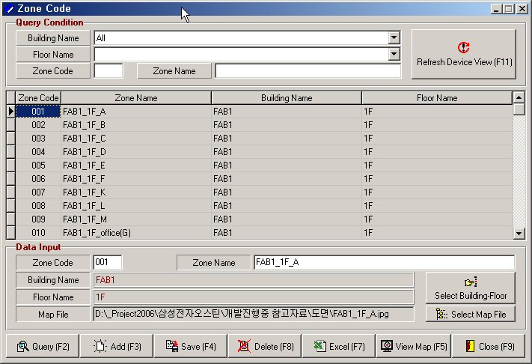
①
②
③
④

- Query condition: Input the query condition.
- Refresh Device View[F11]: if refresh device view, click Refresh device[F11].
If you don’t click this button, you don’t this zone in device view.
- Data Input:
Zone code: Input zone code.
ZONE Name: Input zone name.
Select Building-Floor
Select Map File
- Query[F2]: Execute the Query Condition.
Add[F3]: Create a new zone code.
Save[F4]: Save the Data in the adding or editing data.
Delete[F8]: Delete the Zone code.
Excel[F7]: Export to Excel.
Close[F9]: Close this form.

5.5 Device
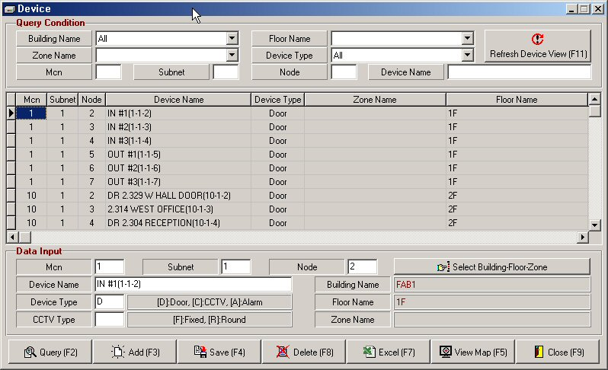
①
②
③
④

- Query condition: Input the query condition.
- Refresh Device View[F11]: if refresh device view, click Refresh device[F11].
If you don’t click this button, you don’t this zone in device view.
- Data Input:
Mcn: Door ➔ Type MCN No
Alarm ➔ Type MCN No
CCTV ➔ Type ‘C’.
Subnet: Door ➔ Type LC No.
Alarm ➔ Type LC No.
CCTV ➔ Type Camera No.
Node: Door ➔ Type SLC No.
Alarm ➔ Type ‘1’ + the alarm Sensor No.
CCTV ➔ Monitor No .
Select Building-Floor-Zone.
Device Name: Input device name or locate called name.
Device Type: assigned SLC ➔ “D”
assigned Door sensor ➔ “A”
assigned CCTV ➔ “C”
CCTV Type: Fixed Type ➔ “F”
Round Type ➔ “R”
Query[F2]: Execute the query.
Add[F3]: Create a new device code.
Save[F4]: Save the Data in the adding or editing data.
Delete[F8]: Delete the device code.
Excel[F7]: Export to Excel.
View Map[F5]: View the Device in the map.
Make the locate of door, alarm and CCTV in map.
If you want to view the real locate of door, alarm and CCTV,
need most make one
Close[F9]: Close this form.

5.6 Assign CCTV
To view Picture of the occurred alarm door, must assign a CCTV.
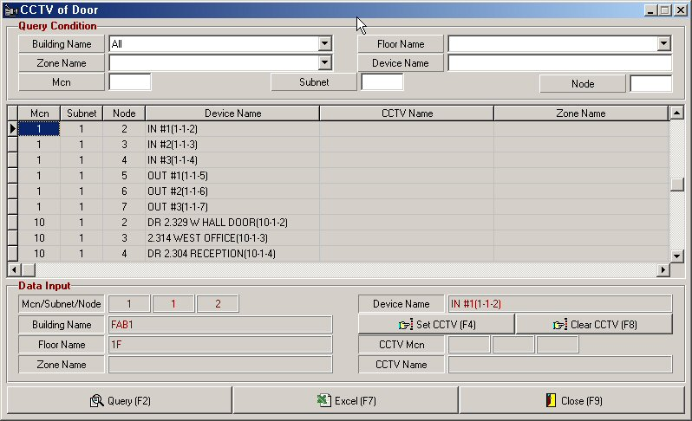
①
②
③

- Query condition: Input the query condition.
- Data Input: To select the CCTV, click Set CCTV[F4]
TO clear the CCTV, click Clear CCTV[F8]
- Query[F2]: Execute the Query.
Excel[F7]: Export to Excel.
Close[F9]: Close this form.

5.7 Member
To want automatic sending alarm message, must create member.
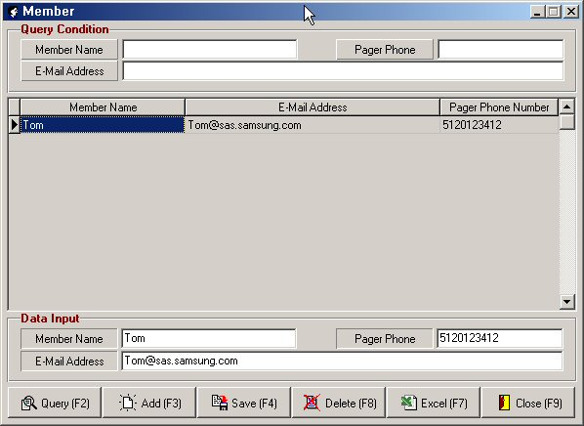
①
②
③

- Query condition: Input the query.
- Data Input:
Member Name: Input the member’s name.
Pager Phone: Input the member’s pager number.
E-Mail Address: Input the member’s email address.
- Query[F2]: Execute the Query.
Add[F3]: Add a member.
Save[F4]: Save the Data in the adding or editing data.
Delete[F8]: Delete member.
Excel[F7]: Export to Excel.
Close[F9]: Close this form

5.8 Member of Send email & SMS
To want automatic sending each alarm message to assign man, create data.
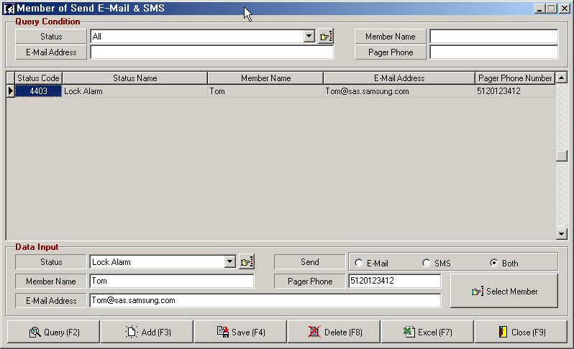
①
②
③

- Query condition: Input the query.
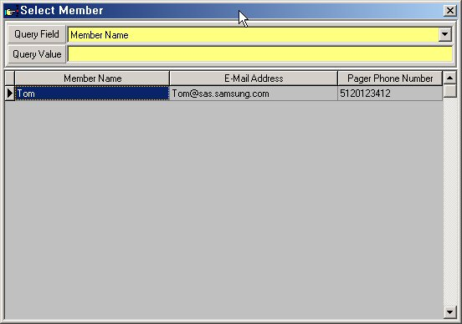
- Data Input:
Status: Select the status code.
Send: Select the type of Send.
Select Member: Select to received member.
- Query[F2]: Execute the Query.
Add[F3]: Add the member.
Save[F4]: Save the data in the adding or editing data.
Delete[F8]: Delete the member.
Excel[F7]: Export to excel.
Close[F9]: Close this form.

5.9 Confirm Message
Use this form to write alarm response that the operator can select when responding to an alarm.
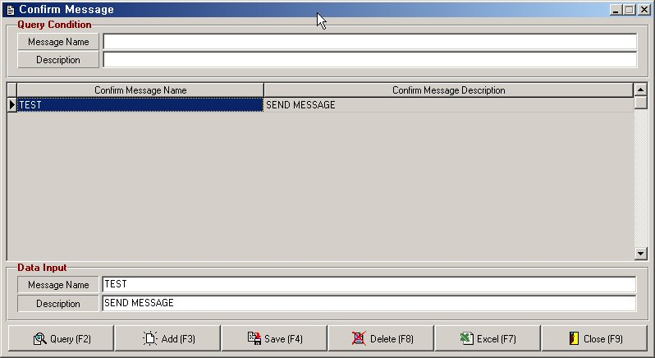
①
②
③

- Query condition: Input the query
- Data Input:
Message Name: Input message name.
Description: Input the message description.
- Query[F2]: Execute query.
Add[F3]: Add message.
Save[F4]: Save the data in the adding or editing data.
Delete[F8]: Delete Data.
Excel[F7]: Export to Excel.
Close[F9]: Close this form.

6. MAIN SCREEN

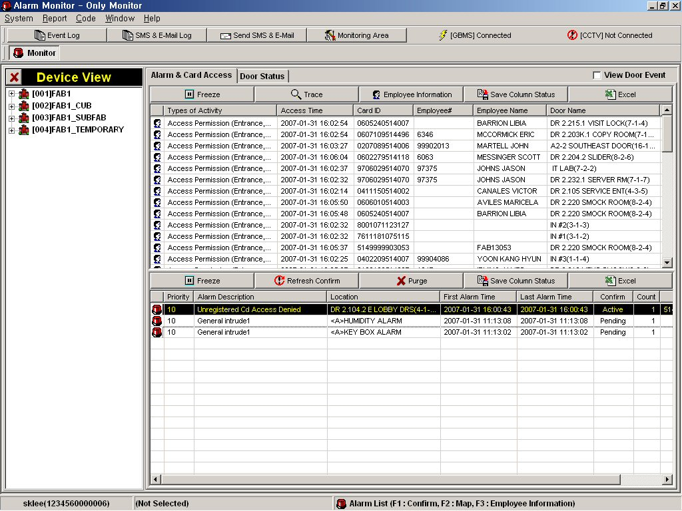
6.1 Main screen layout
②
③
④
①

- Hot menu
- Status of network: display the GBMS and CCTV connected status.
- Device view: display the buildings, floors, zones and devices.
- Event View: Display the alarm and card access data.

6.2 Device View
Display the device information by Tree view.
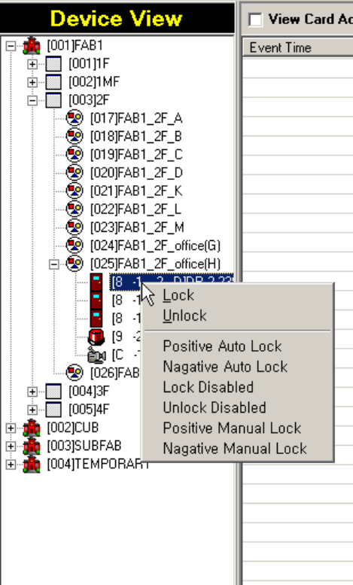
To remote control device, click mouse right button
①
②
③
④
⑤
⑥
in the only master mode.

① Building
② Floor
③ Zone:
④ Door(SLC):
⑤ Door(Sensor):
⑥ CCTV:

6.3 Card access view
To enable show a reading card.
To enable show information of reading card.

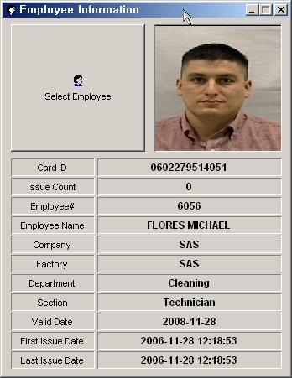

④

- Freeze: Freeze the display of a reading card data.
View Door Event: Display the door open/close status.
- Trace: When you want to trace a particular card, press this button.
- Employee information: When you want to view a information of particular card,
press this button
- Save Column status: When you want to save the current column locate, press this button.
- Excel: To expert excel.

6.4 Alarm view
Show occurred alarm.
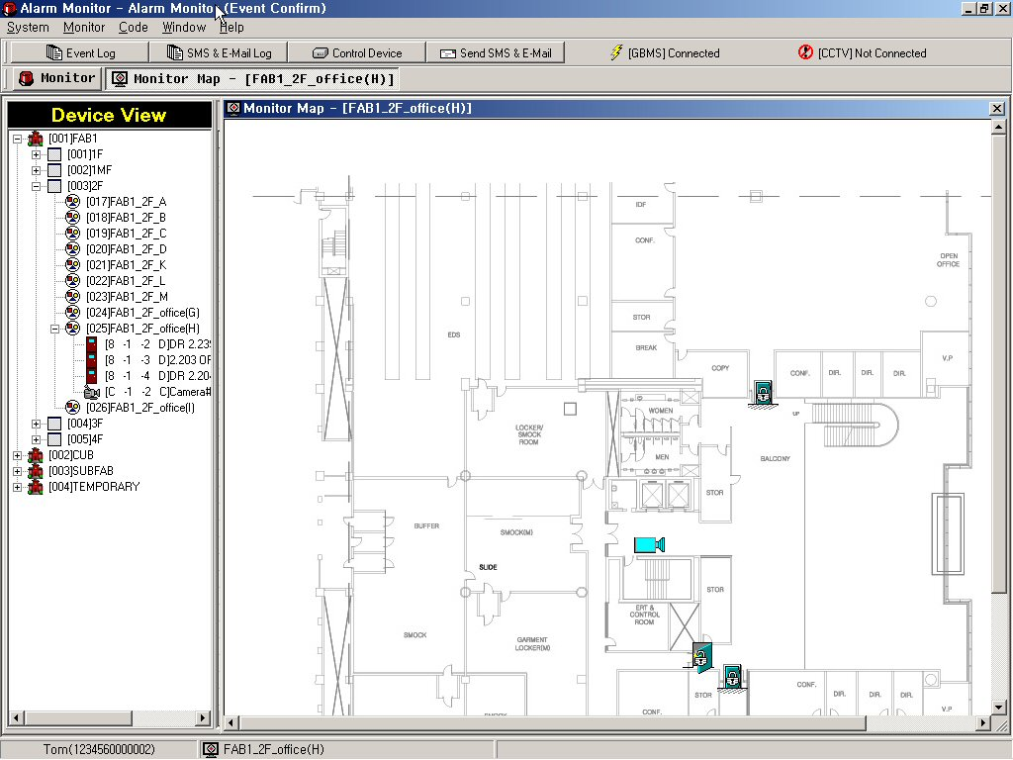
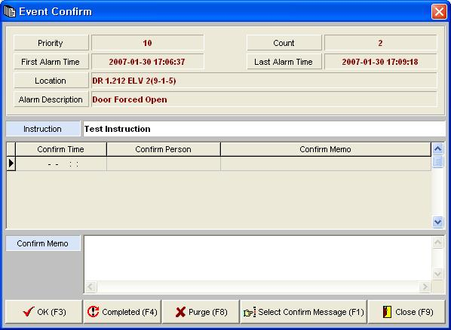
Double click Left
mouse button
Single click right
mouse button

  - Freeze: Freeze the display of a reading card data.
view Door Event: Display the door open/close status.
  - Refresh Confirm: Refresh Confirm status in DB.
  - Purge: Delete event data in the event Grid . (not delete data in DB)
Excel: Export to Excel in the event grid.
  - View event

6.5 Door status view
You can view the all door status.
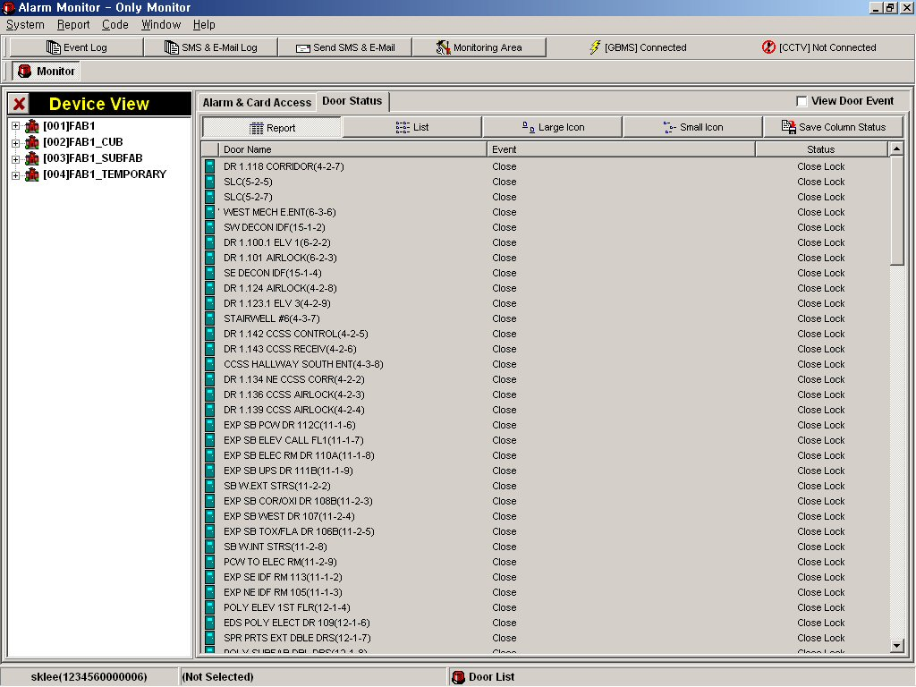

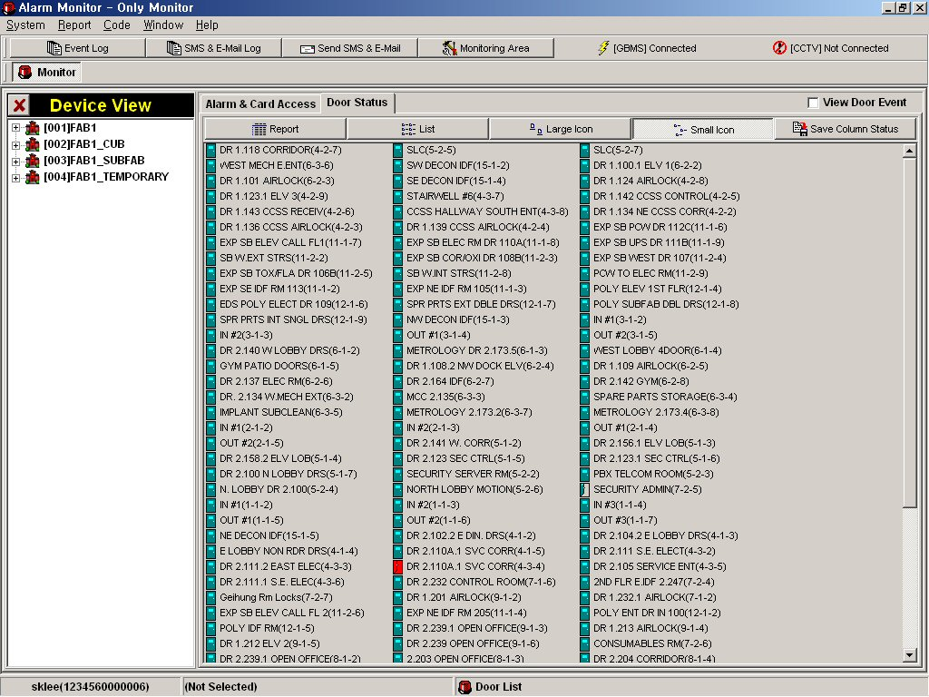
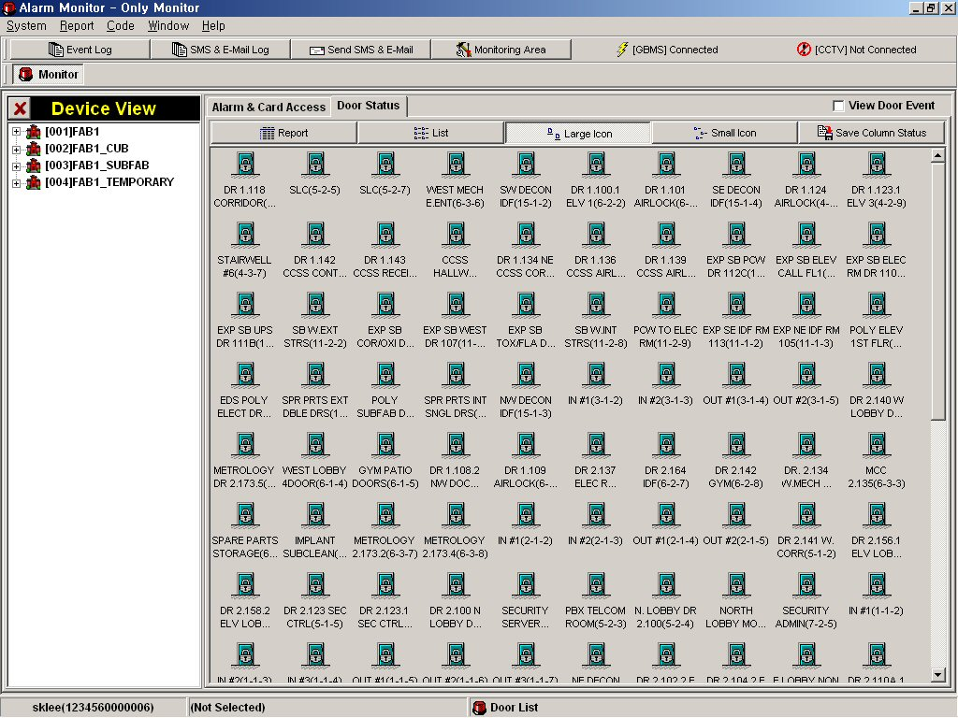

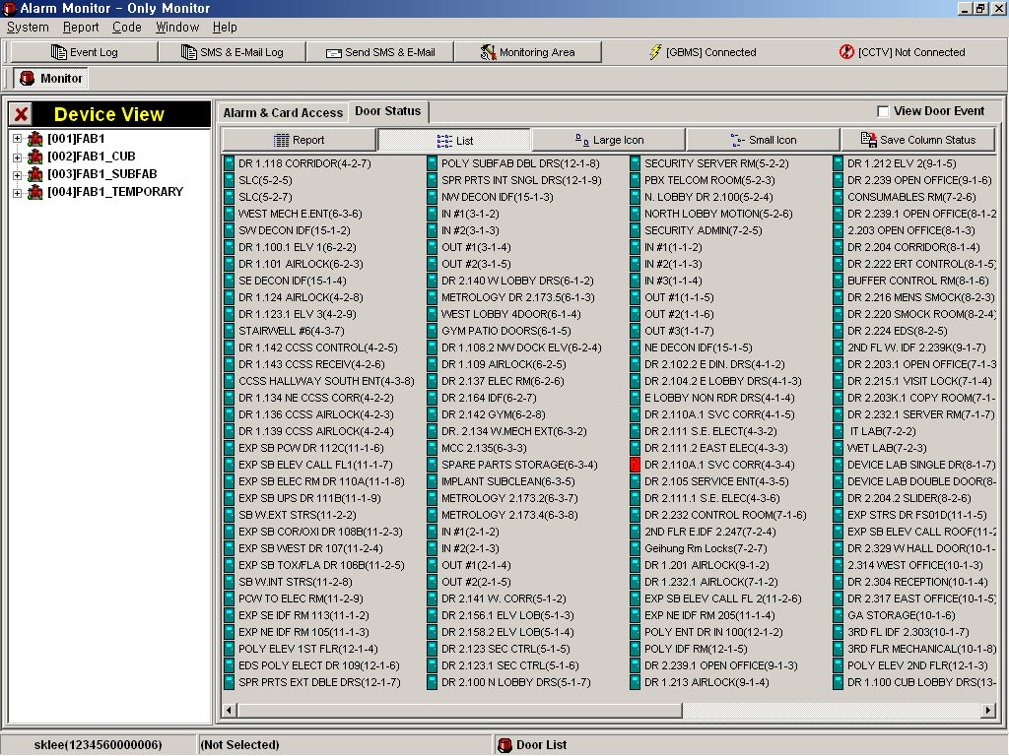

6.6 Map View
Display door and CCTV icon in map.
To view map screen, click zone or device in the device view.
You can find the real locate door and cctv in the map
You can view popup menu to select door and click mouse right button.
You can image to select the icon of CCTV and click mouse right button.

6.7 Send SMS & E-Mail
Send message to member.
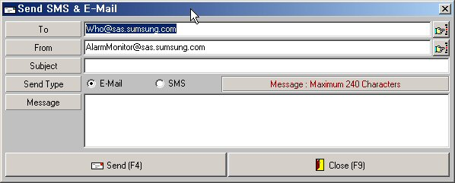
①
②
③
④
⑤

- Input the member’s email address.
- Input the sender’s email address.
- Input the subject.
- Select send type.
- Input message.
- To send, click Send[F4].

7. Report

7.1 Event log
Report the event data and export to excel.
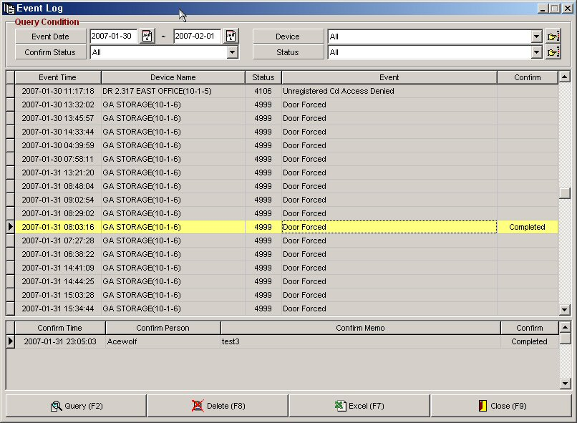
①

②

- Query Condition: Input the query.
- Query[F2]: Execute Query.
Excel[F7]: Export to Excel.
Close[F9]: Close this form.

7.2 SMS Log
Report the SMS and Email log and export to excel.
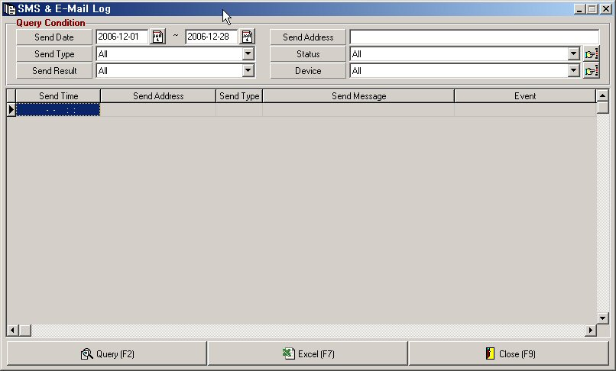
①

②

- Query Condition: Input the query.
- Query[F2]: Execute the query.
Excel[F7]: Export to Excel.
Close[F9]: Close this form.

7.3 Card Access Log
Report the card access and export excel.
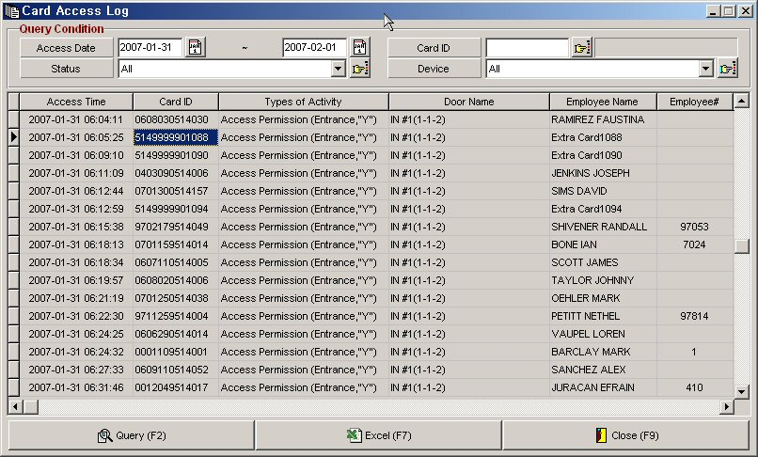
①
②

- Query Condition: Input the query.
- Query[F2]: Execute the query.
Excel[F7]: Export to Excel.
Close[F9]: Close this form.

7.4 Admin Log
Report the admin log.
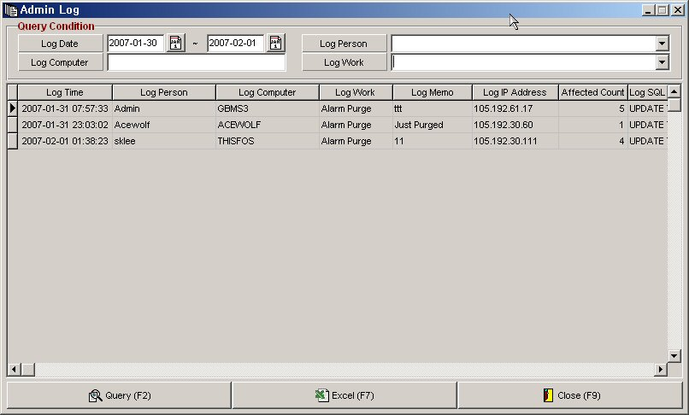
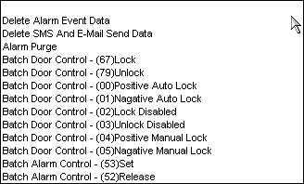
①
②

- Query Condition: Input the query.
- Query[F2]: Execute the query.
Excel[F7]: Export to Excel.
Close[F9]: Close this form.

